# Brief insight on how I did it.......

# Task1 by 24BCE2001-Satvik Sinha (interview candidate for prometheus club)

First part of any machine learning model being successfull is the dataset that is used to train it.

In this process I made a dataset for task 1, This included searching pictures for The dataset to be trained on. The first task was to find the suitable pictures to be included in the dataset. Preferrably since our model was only supposed to identify balls, grey scaled images were choosen as the model will have to only detect wether object from dataset was present in the scene or not and return 1 as value ,this would help increase model efficiency compared to RGB pics used in training and also leads to higher accuracy.

Step1: Search the images and save on the local computer and convert it to Grey scale if only RGB Available

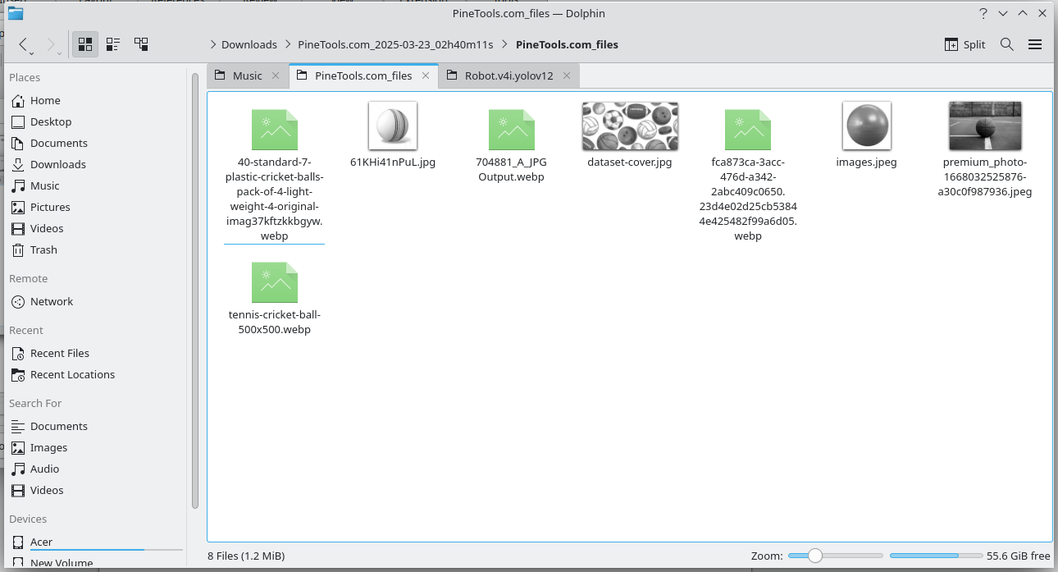

**Step2: It Involved uploading the greyscaled images to Roboflow for dataset creation**

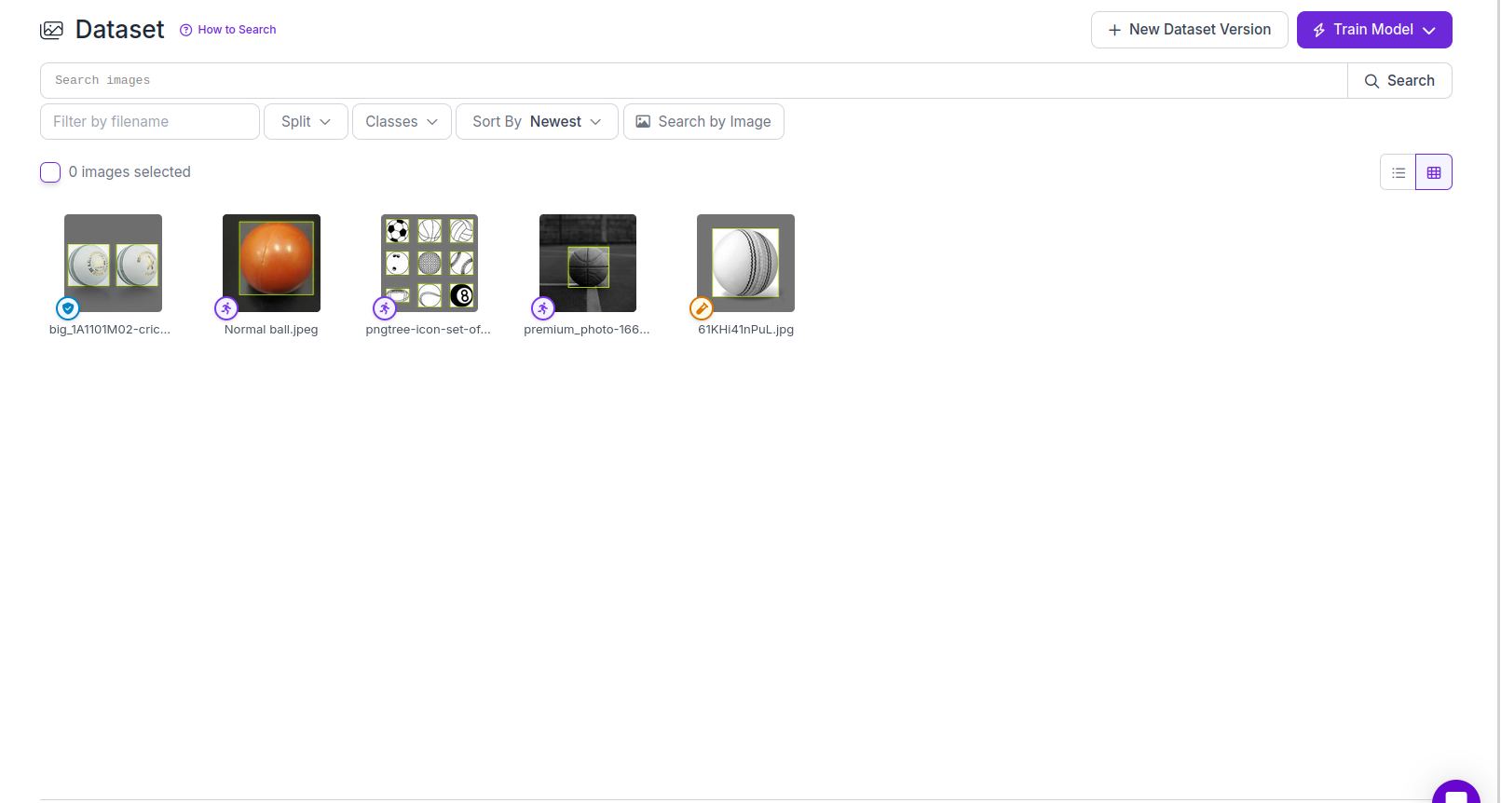

**Since we were limited to only 20 images ,One of the images that proved to be benificial was types of balls in one single image.**

**The object in the pic were highlighted using the Roboflow’s inbuilt ai labelling system ,images were spilit into batches of test, train and valid set. As these 3 were required in data.yaml for Our YOLO V8 model to be trained on.**

**AS the dataset was created , it was rigorously tested alongside which helped in futher improving the dataset to be used in model. It took 20 runs for the model to give accurate results**

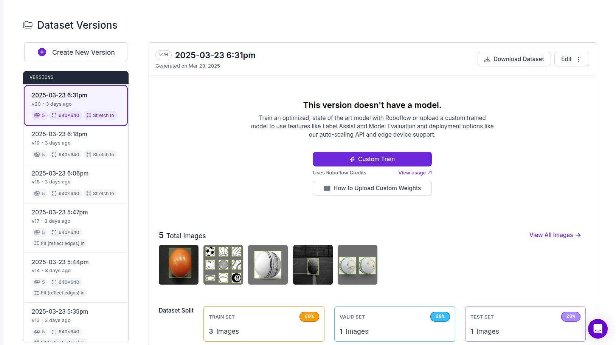

**Leveraging the power of NVIDIA RTX3050 with tensor cores and linux installation with required AI libraries on board my own system , the model was able to be trained faster. As everything was already setuped for regular AI/ML projects**

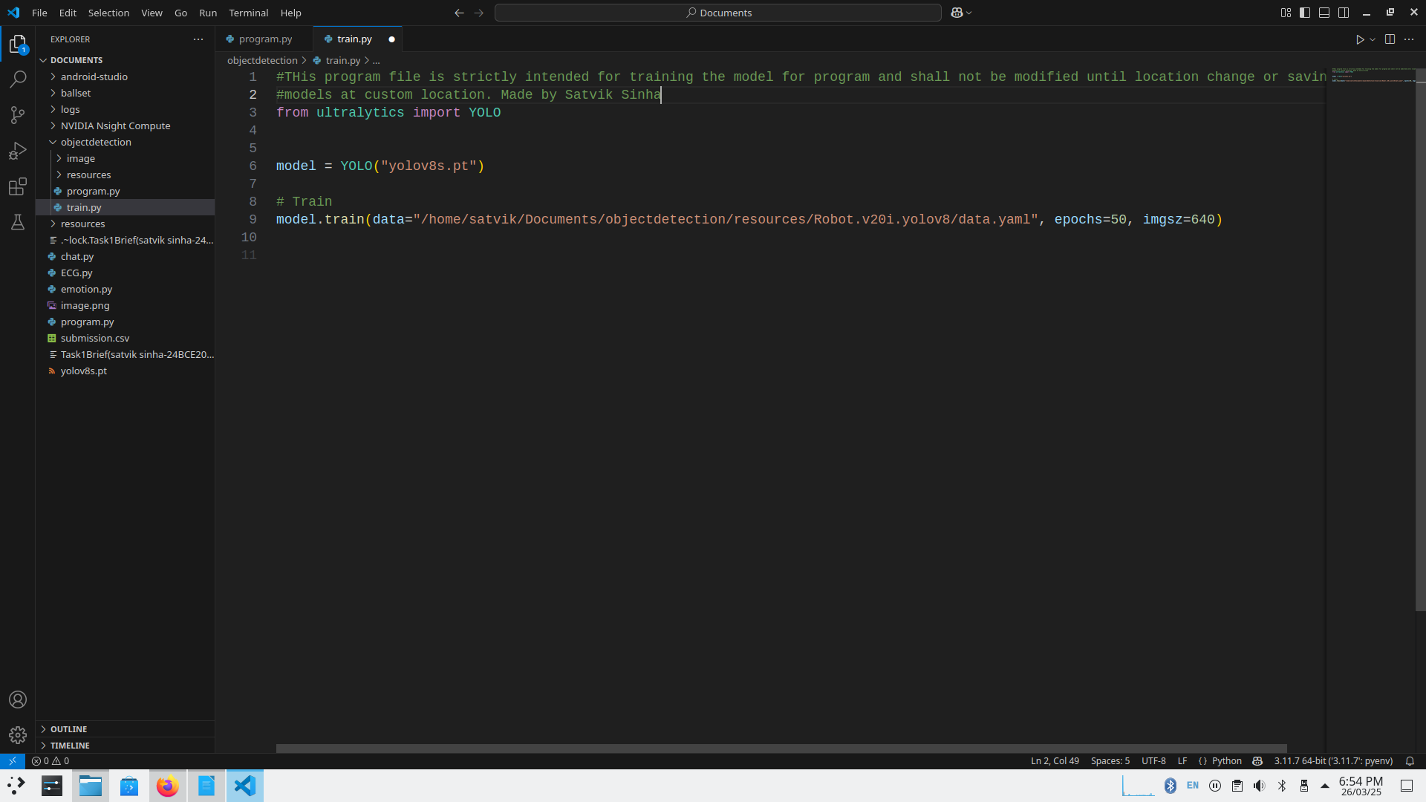

**The reason why YOLO V8 was choosen because it had adequate documentation and was actively supported by Roboflow.**

**Once good model was achieved It was accessed from the saved location on the disk and was then utilised to detect ball in real time with open cv library**

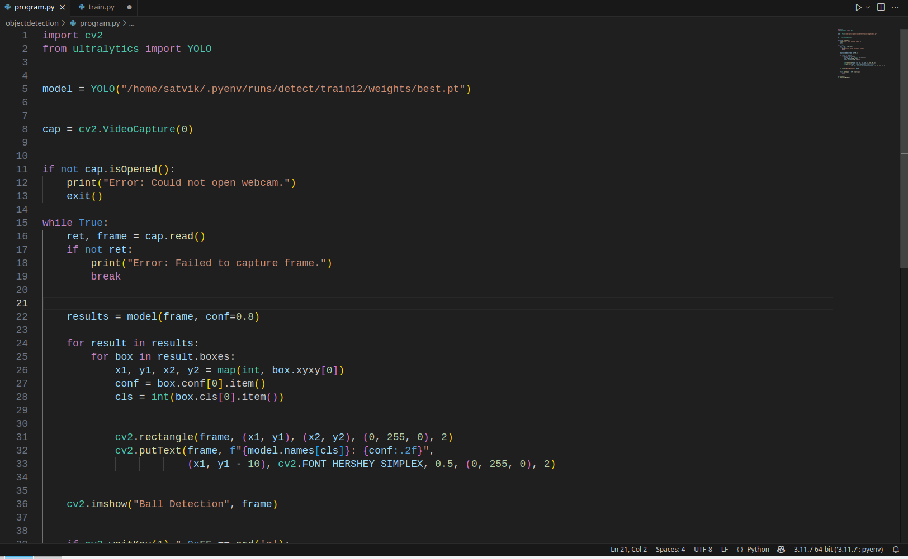

**At last we achieved a Model with good accuracy and high confidence in object detection.**

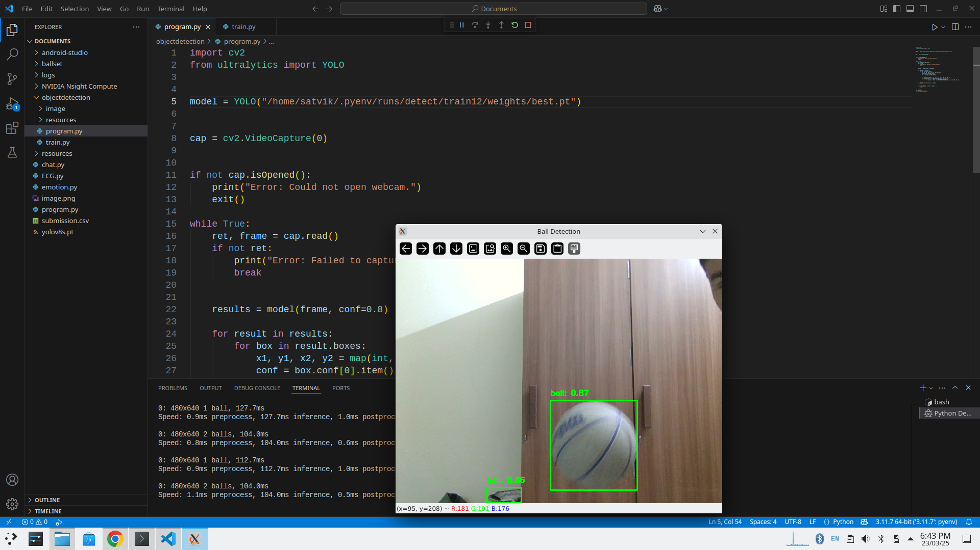**`**

**The model was able to detect a bouncing ball with 0.87 confidence on a scale of 0 to 1 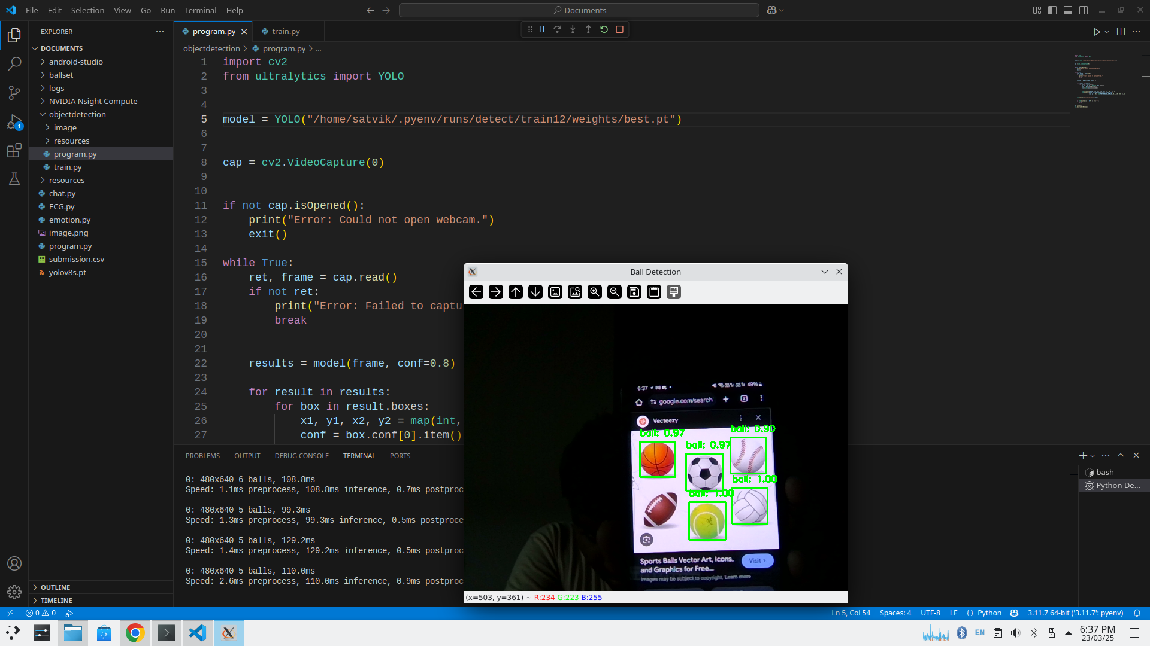.**

**Even was photo of ball in the phone could be easily detected by the model**

